1. After installing git, create a git repo on your local system.
2. 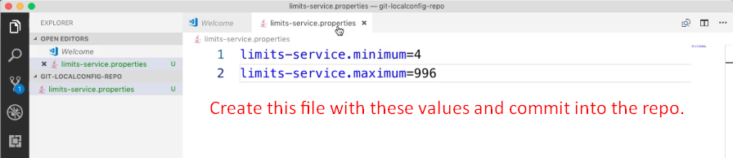
3. 